DESIGN GALLERY
EXISTING SITE
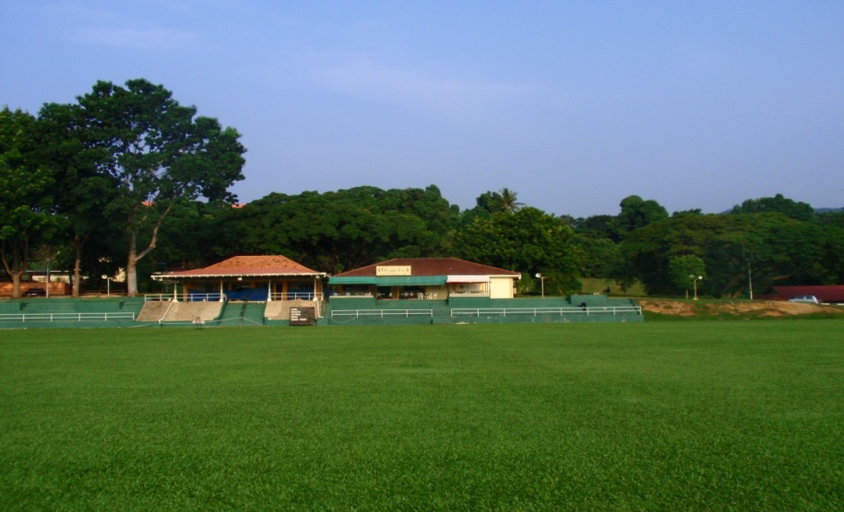
- Our site is situated at the East side of USM Main Campus.
- It is right beside the school field.

SITE POTENTIAL

PLAN PRECINCT
- Our site has a big potential to be a Design Gallery because it is situated at a strategic place.
- It is very near to the East Gate of USM.
- It is surrounded by swimming pools, recreation site and important buildings such as the information office. People who do exercise at the field and swimming pools will surely pass by our site. Besides that, students can visit the design gallery conveniently after finding information at the information office.
- Our site can be a perfect place for students and visitors to relax after the tiring session of games.
- Our site is enclosed by tall trees and plants which can provide a cool and fresh environment.
- There is a existing car park at our site where visitors can put their cars there.
- Our site is a small long piece of land. It is not suitable for us to build a tall building because there are trees blocking behind our site.
- With the set up of our design gallery, we can attract more people to come to the East side of USM.

IDEAS AND THEORY
- The intention of developing our site is to improve the use of land of USM and at the same time put our effort on maintaining the APEX status.
- After observing and analysing our site, we decided to propose a design gallery.
- Our concept of designing the gallery is based on the seven crucial points proposed by our Vice Chancellor which are :
      - Uncertain Future
      - Unique
      - Sustainable
      - Humane
      - Universal
      - Changeable
      - Commitment
- In order to achieve sustainability, we emphasise on the importance of nature. Hence, we maintain the trees and plants surrounding the gallery.
- We create a futuristic design because we want our gallery to be in a line with this modern era. A futuristic building design surrounded by the green environment is very unique as it combines both nature and man-made.
- Our design gallery can be a place for students to exchange valuable ideas. Besides that, students can also get inspiration from the resources in our design gallery. This can increase the creativity of students.
- Apart from that, our gallery can be a place for international students or visitors to explore Malaysian culture as most of the works in the gallery is based on local design such as bamboo design, sarong and batik.

CONTRIBUTION TO APEX USM
- With the construction of our design gallery, students’ design work can be exhibited to the public. This contributes to APEX USM by showing students capability in designing and constructing.
- People will be amazed with students’ creativity and appreciate students’ potential. This will preserve the work standard of our students.
- The achievement of our gallery will increase the reputation of USM not only in Malaysia but also in other countries.
- There will be more international universities that recognise APEX USM. Therefore, more international students will be interested in coming to USM.

DETAILS OF OUR DESIGN GALLERY
Signboard
- This is a new developed place. The signboard can help people in determining the right direction so that they won’t get lost.
Sculpture
- The design of our sculpture is based on space and form. The joining of different structures gives an architectural effect.
Design Of The Building
- We include a lot of glass in our design so that people can see the interior design of the building including unique design structures. This can attract their attention to come to our gallery.
- At night, we use different colours of light to shine on different windows to give a colourful effect.
- The bulging windows on the middle of the building shows forms and spaces which are important elements in design.
- Automatic doors are used to ease people from getting in and out of the building.
- We choose grey as the colour of the building because it has a sense of mysterious but people can explore colourful design inside.
Exit Of The Gallery
- The main exit of the gallery faces the recreational site, where people can go to relax after visiting our gallery.
- The other exit is facing the car park. People can go to the car park conveniently.
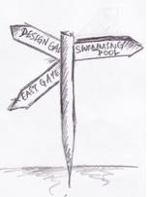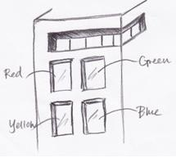
BIODIVERSITY & ITS RELEVANCE TO USM : MAMBU TREE
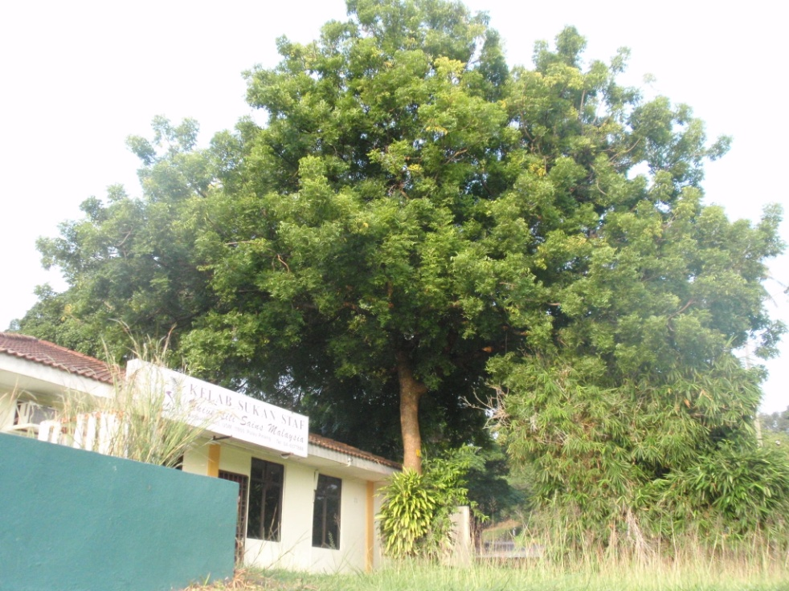
Family Name: Meliaceae
Botanical Name(s): Azadirachta Indica
Popular Name(s): Lilac, Margosa tree, Neem, Neem chal
Parts Used: Leaves, Flower, Oil, Seed
Habitat: Grows throughout India.
Description: This tree is found in the Western Himalayas of India and in Iran. It is cultivated in other parts of India and the tropical regions of the world such as Indonesia, Australia, and West Africa. It is considered to be a very valuable herb in Ayurvedic medicine and is used for a variety of folk applications.
Uses: This herb is used in inflammatory and febrile diseases. It is also used for worm infestation. It is used for a variety of conditions in Ayurvedic Medicine, singly and in combination. Root bark possesses astringent, tonic and antiperiodic properties. It is also useful in Malarial fever. The oil is used in making Neem based soaps, shampoos and toothpaste.

DEFINITION OF BIODIVERSITY
- Wikipedia
Biodiversity is the variation of life forms within a given ecosystem, biome, or for the entire Earth. Biologists most often define "biological diversity" or "biodiversity" as the "totality of genes, species, and ecosystems of a region".
- Green-Networld
The number and variety of different organisms in the ecological complexes in which they naturally occur. Organisms are organized at many levels, ranging from complete ecosystems to the biochemical structures that are the molecular basis of heredity. Thus, the term encompasses different ecosystems, species, and genes that must be present for a healthy environment. A large number of species must characterize the food chain, representing multiple predator-prey relationships.
WHY IS BIODIVERSITY RELEVANT TO USM?
In our opinion, biodiversity is relevant to USM because USM is using the concept of “University In The Garden”. The concept emphasise on the preservation of natural environment. Although we explore lands to build faculties, we still maintain the original greenary. Unlike other development which destroy nature without thinking the effect to the ecological system, USM is encouraging students to be close to nature. For example, we can see trees all over the campus. We need to be aware that trees not only provide people with shelter but also provide cool and fresh air. Since there is a good maintenance of ecosystem in USM, many species choose USM as their new habitat.
With biodiversity in USM, students especially those in Biology field can do research and understand organisms better where different species can be identified. Besides that, with the massive number of trees that produce the cooling effect, students can have a comfortable environment for the process of learning. Nice scenery of flora and fauna can reduce stress of a university student.
In conclusion, biodiversity is very important to ensure the continuity of species. With the preservation of nature, the ecosystem will not be affected. The interdependence of human and environment can be sustained.

DIVERSIFIED SPECIES AT OUR SITE
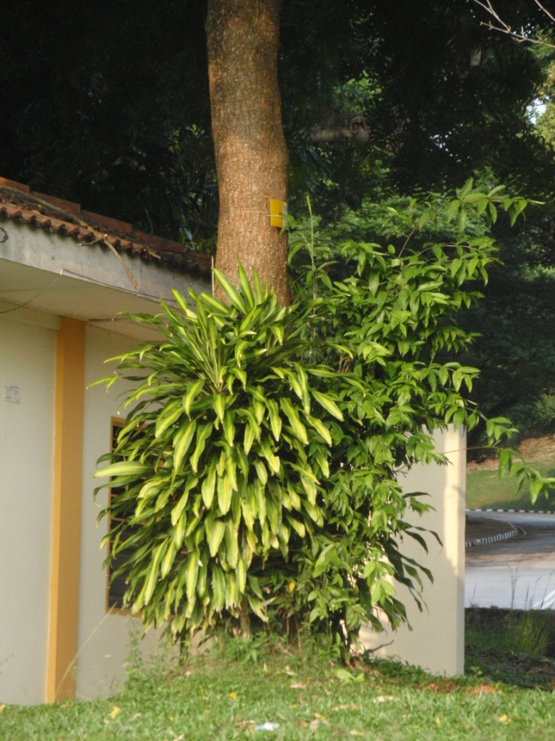
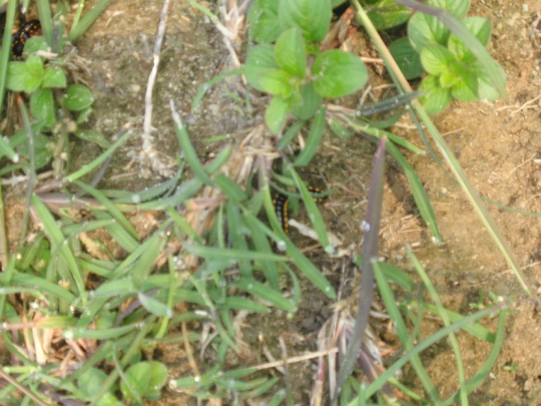
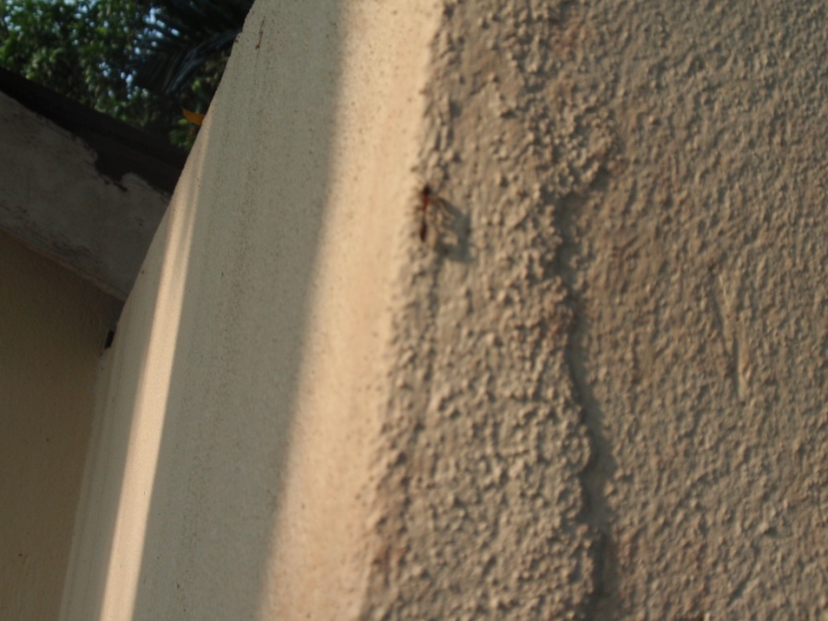

INTERESTING DESIGN DETAILS

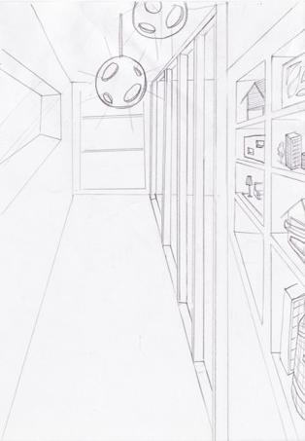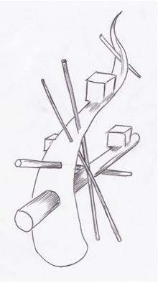
BEFORE AND AFTER
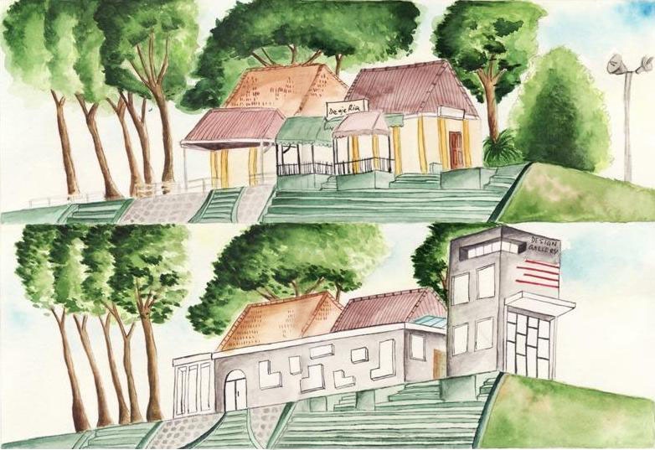
>5000

On our site, we discover some of the species such as birds, parasites, ants and worms. Through the long day of our observation and analysis, we have come out with an approximation figure. We estimated the birds are around 100, particularly in the evening. Besides that, there are about ten parasites on our site. Out of two parasites are on our Mambu tree. Next, the highest quantity of species on the site is ants. We estimated that the number of ants is more than 5000. The last species that we found is worms. It is about 25 on the site.

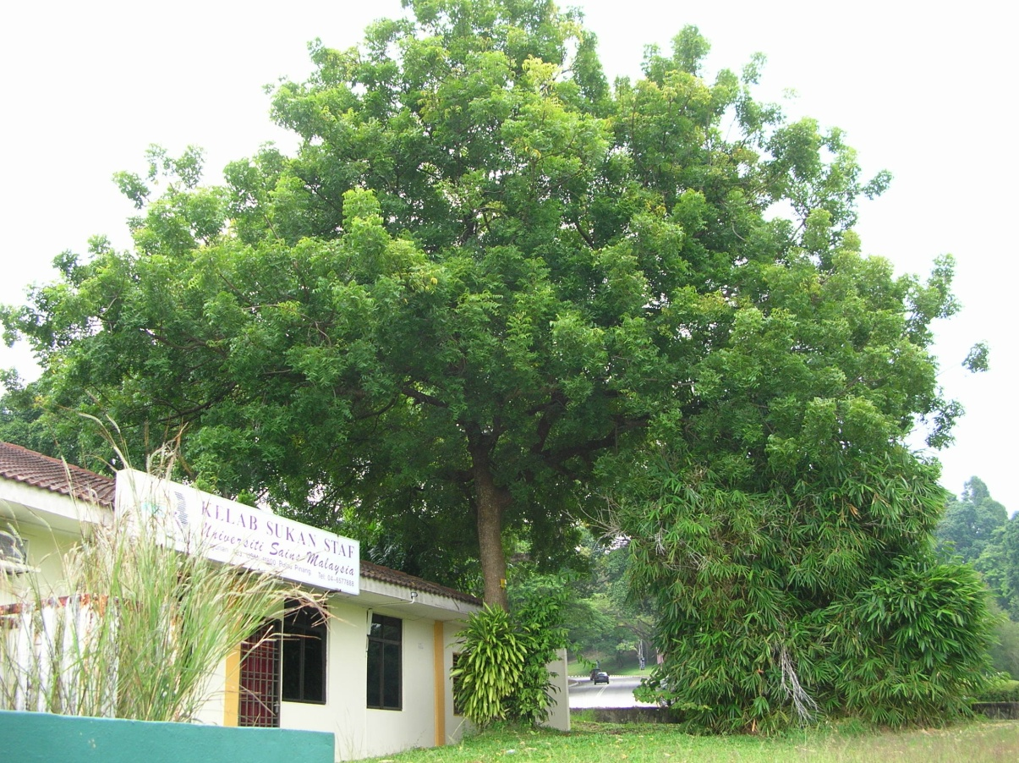
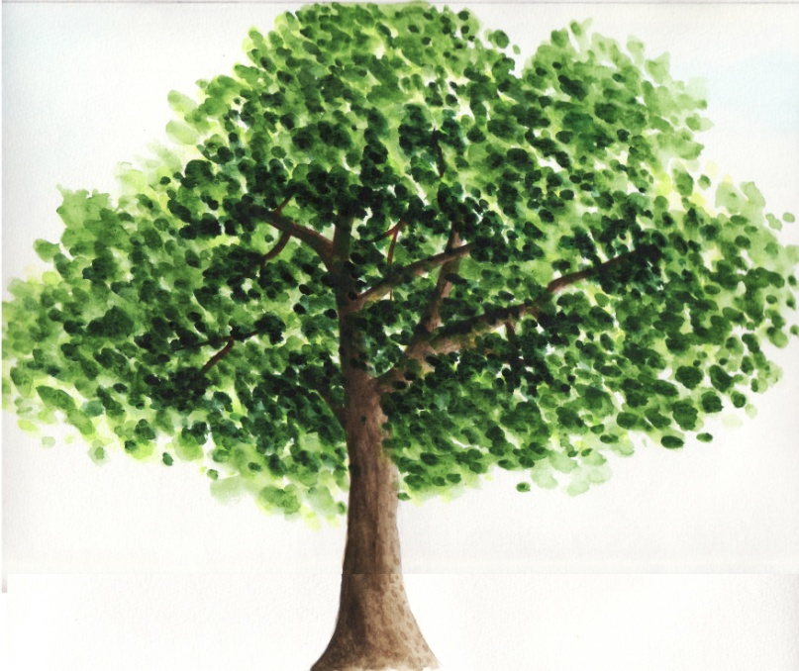
Canopy Size : 5005 millimeter
Girth : 1285 millimeter
Morning Shadow : 9880 millimeter
Afternoon Shadow : 4250 millimeter

